**SQL:**

**Question: 1**

**Given the following tables:**

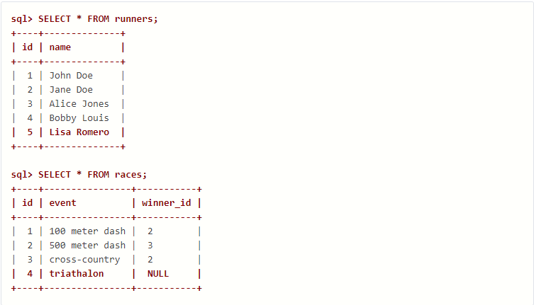

**What will be the result of the query below?**

**SELECT * FROM runners WHERE id NOT IN (SELECT winner_id FROM races)**

**Explain your answer and also provide an alternative version of this query that will avoid the issue that it exposes.**

Answer:

SELECT * FROM runners WHERE id NOT IN (SELECT winner_id FROM races)

This query selects all records from the 'runners' table where the 'id' of the runner is not found in the 'winner_id' column of the 'races' table.

This query has an issue, 'winner_id' column in the 'races' table contains NULL values.

**the alternative version using LEFT JOIN of this query that will avoid the issue:**

**```**

**SELECT runners.\***

**FROM runners LEFT JOIN races**

**ON runners.id = races.winner_id**

**WHERE races.winner_id IS NULL;**

**```**

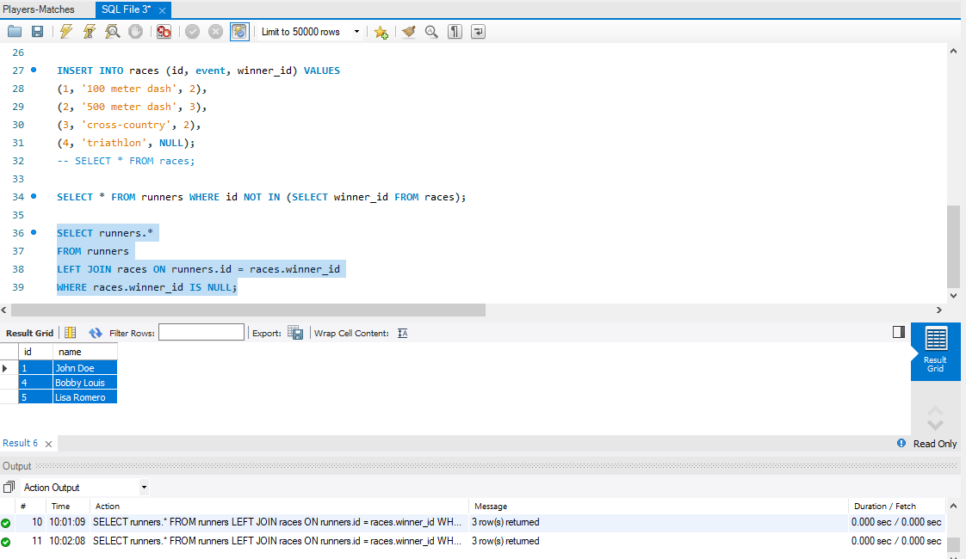

________________________________________________________________

**Question: 2**

Given two tables created as follows

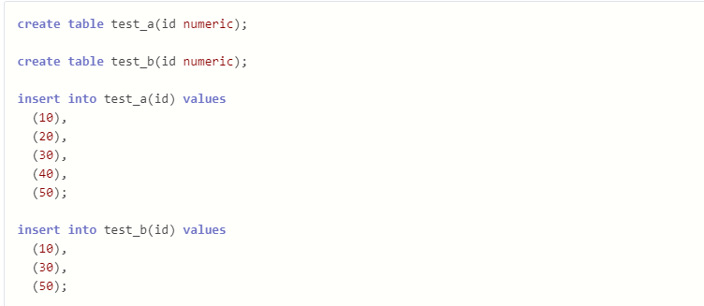

Write a query to fetch values in table test_a that are and not in test_b without using the NOT keyword.

Answer:

SELECT a.id

FROM test_a a

LEFT JOIN test_b b ON a.id = b.id

WHERE b.id IS NULL;

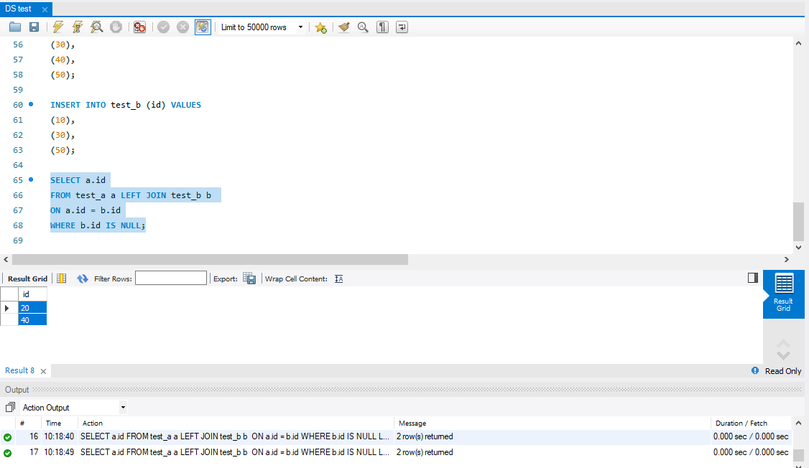

__________________________________________________________________________

**Question: 3**

Given the following tables:

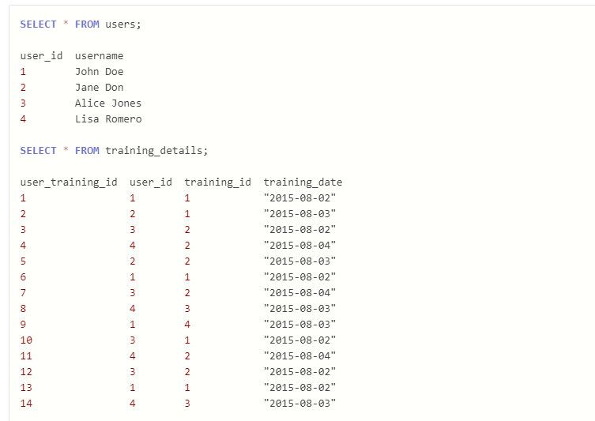

Write a query to to get the list of users who took the a training lesson more than once in the same day, grouped by user and training lesson, each ordered from the most recent lesson date to oldest date.

Answer:

SELECT u.user_id, u.username, td.training_id, td.training_date

FROM users u

JOIN training_details td ON u.user_id = td.user_id

WHERE td.training_date IN (

SELECT training_date

FROM training_details

WHERE user_id = u.user_id AND training_id = td.training_id

GROUP BY user_id, training_id, training_date

HAVING COUNT(*) > 1

)

ORDER BY u.user_id, td.training_id, td.training_date DESC;



